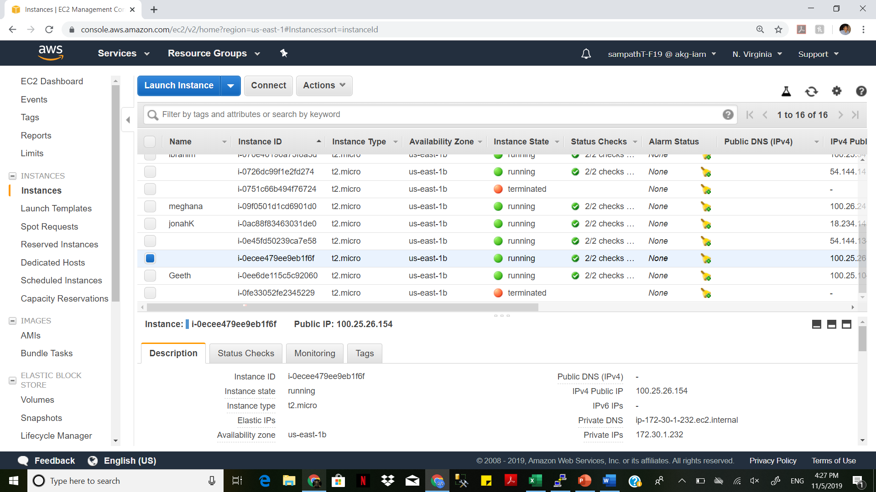

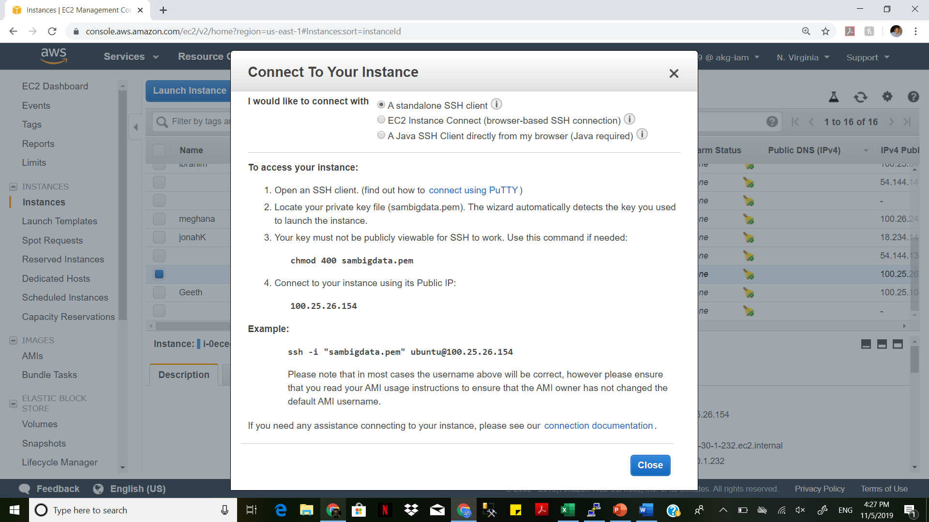

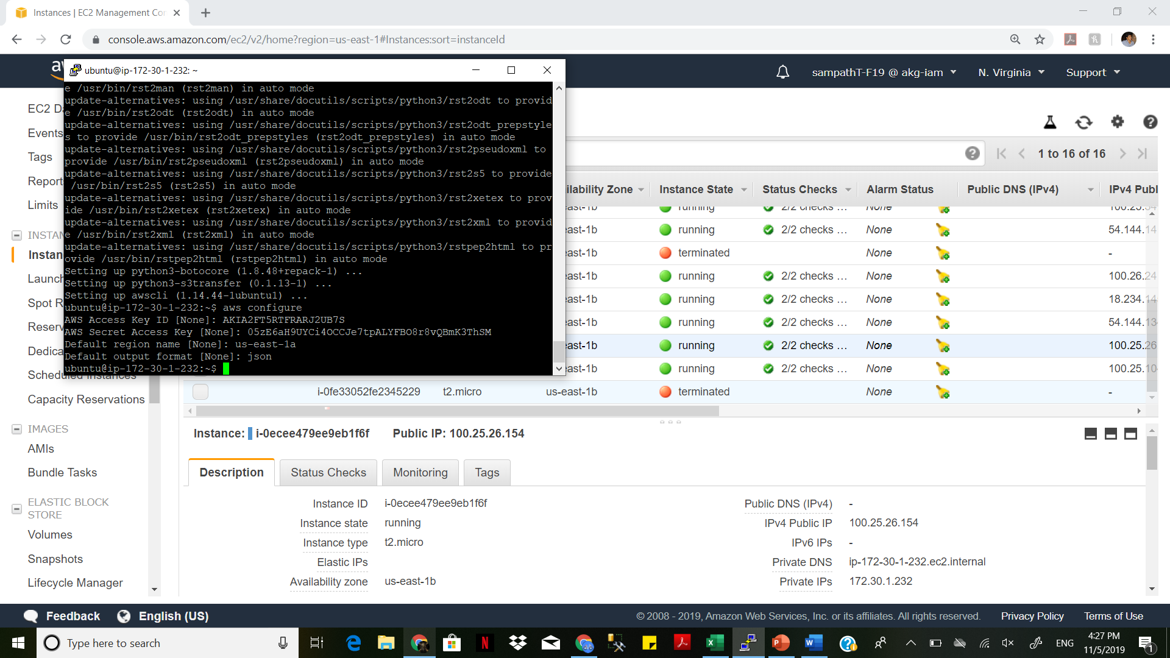

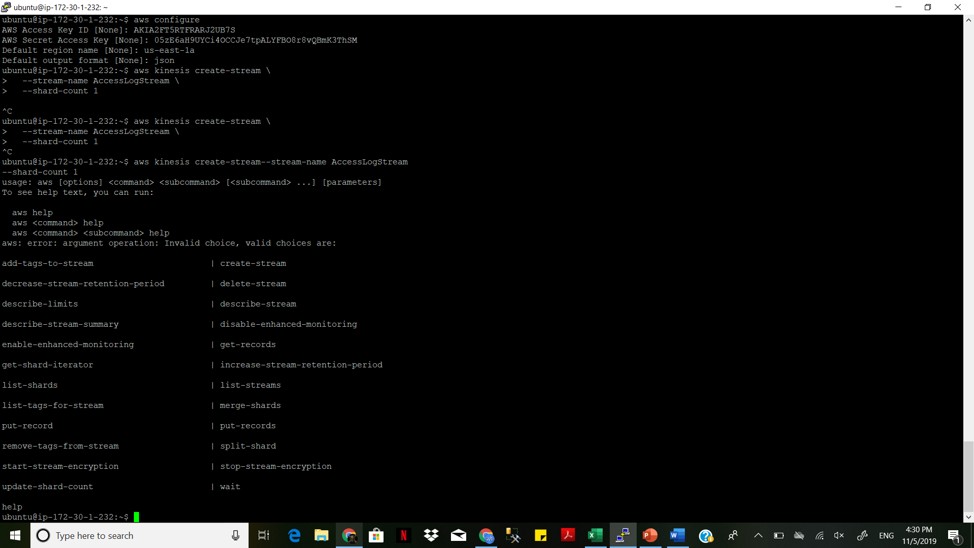

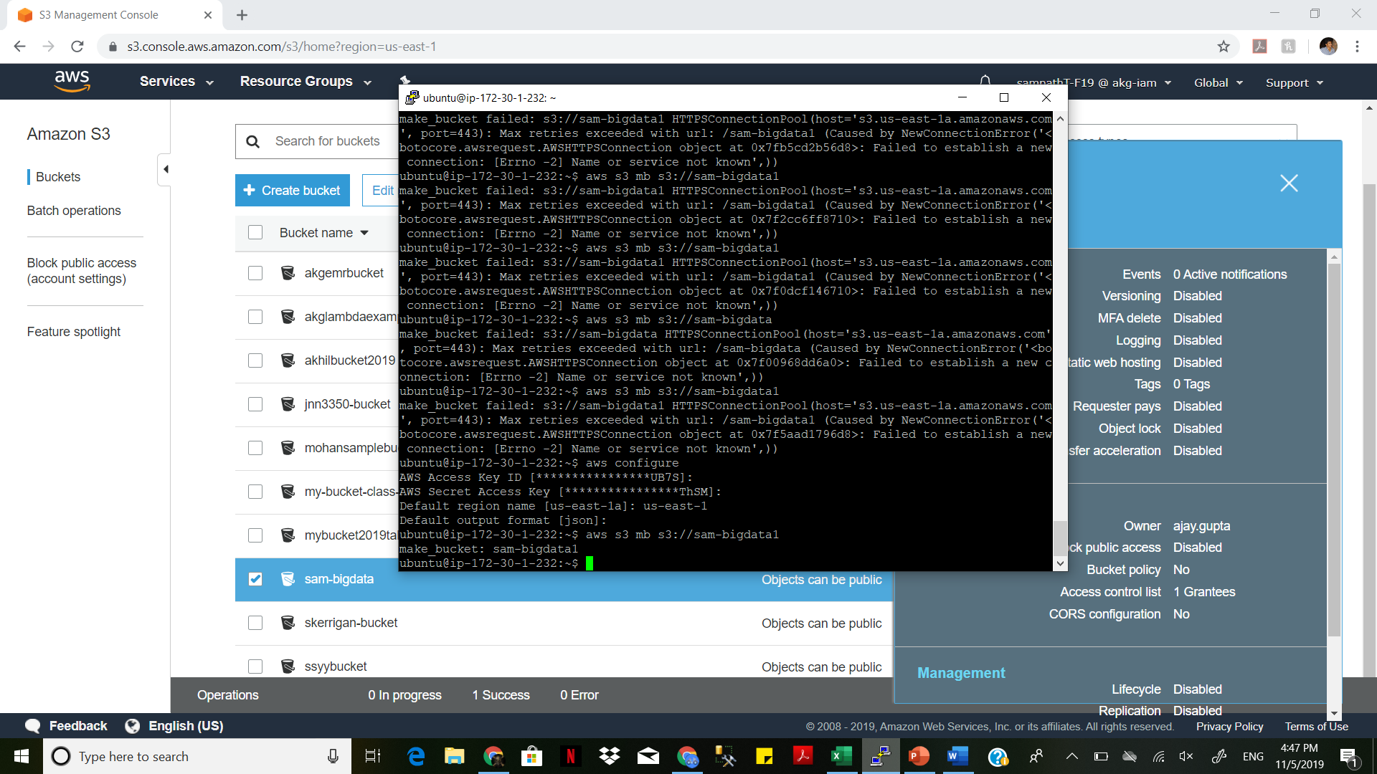

ubuntu@ip-172-30-1-232:~$ aws emr create-cluster --name "samdemo" --instance-type m4.xlargeubnetId=subnet-04d3ef7946ad9b5e4 --use-default-roles --applications Name=Hive Name=Spark

{

"ClusterId": "j-2OF6RFG6KOAMQ"

}

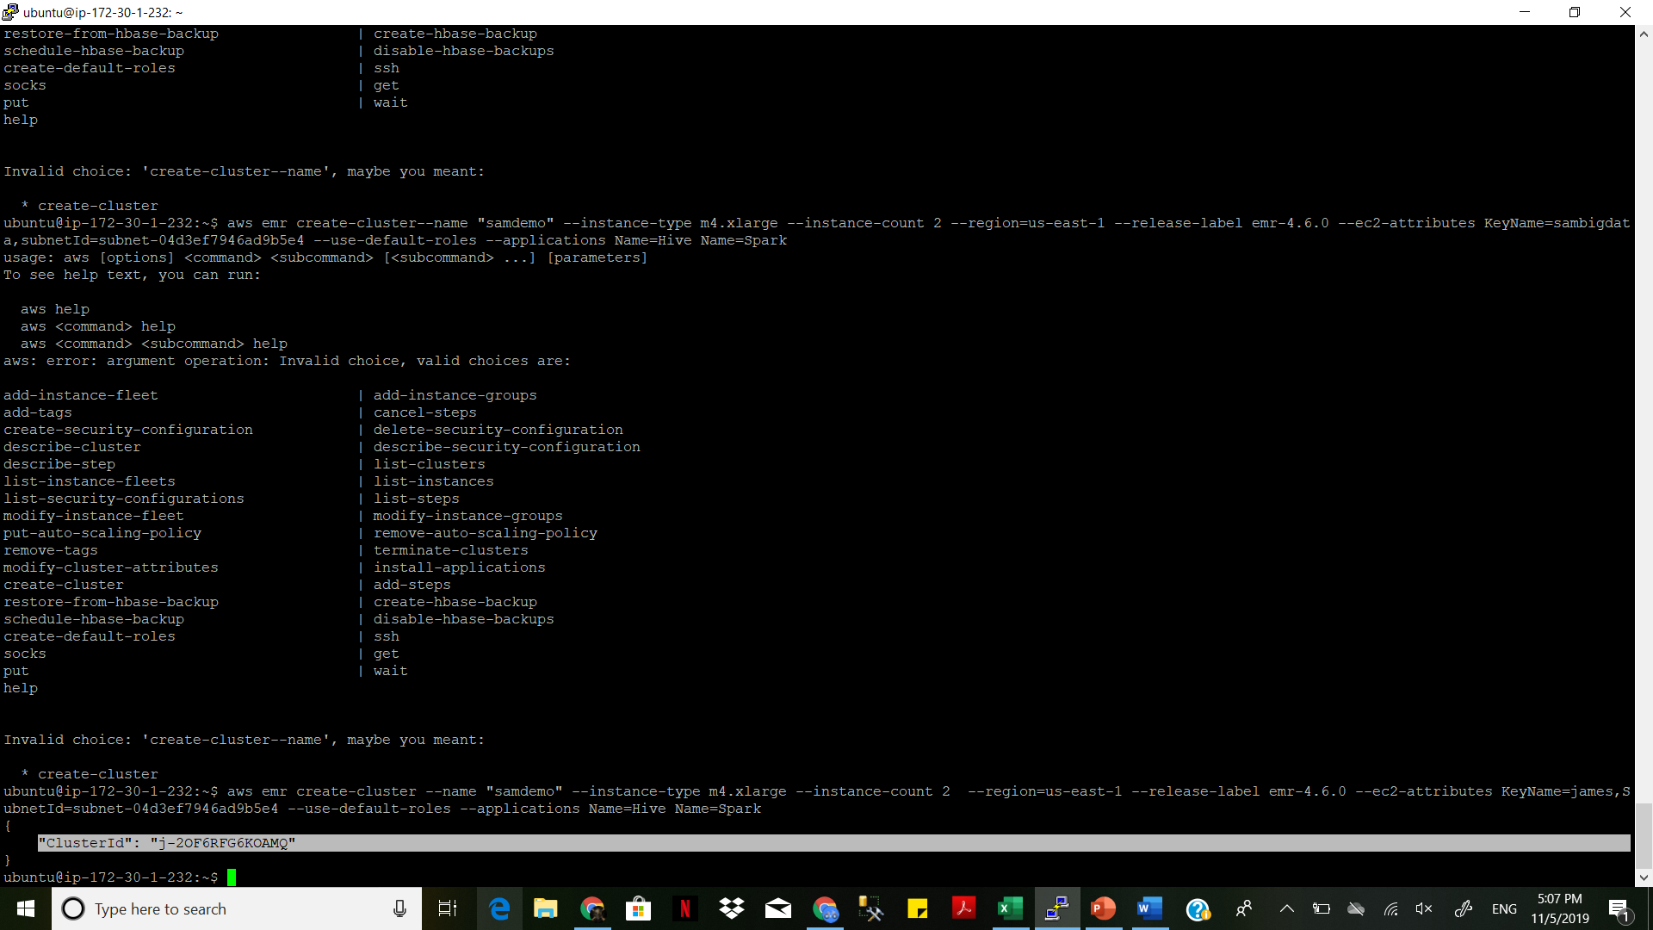

aws redshift create-cluster --cluster-identifier samdemo --db-name samdemo --node-type dc1.large --cluster-type single-node --master-username master --master-user-password ABCabc143 --publicly-accessible --port 8192

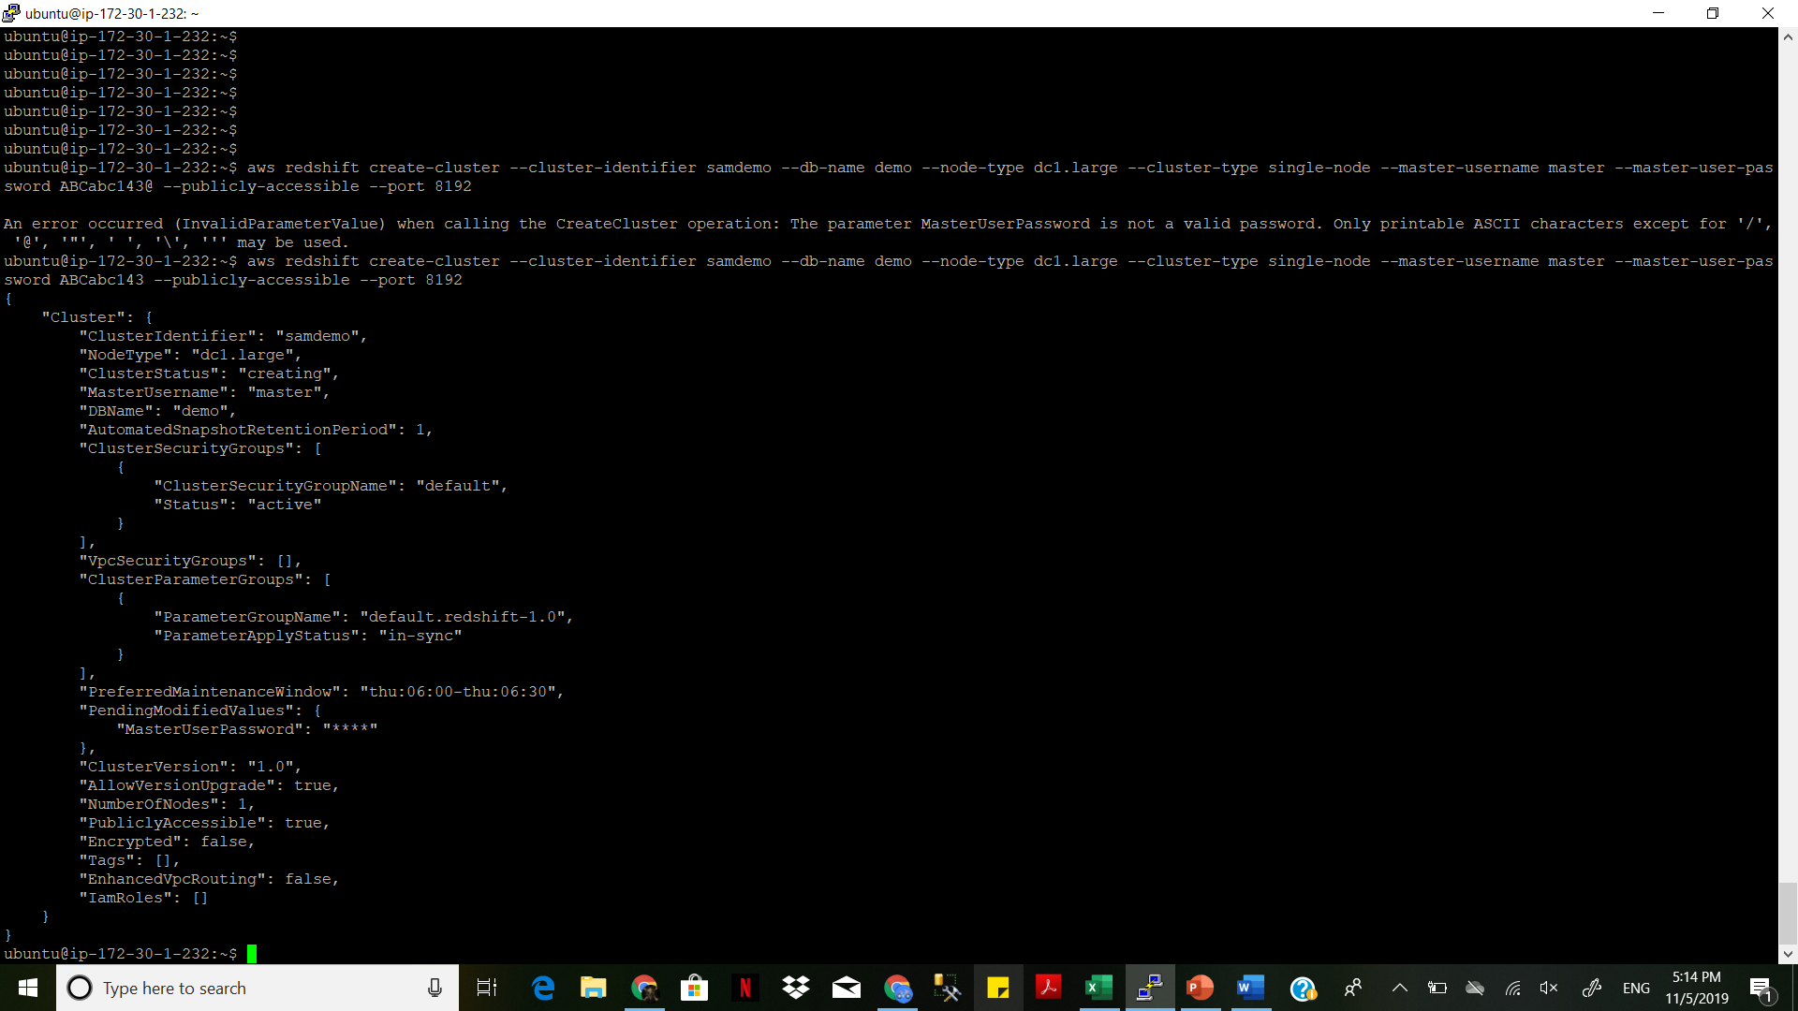

Master user name: master

Password: ABCabc143

DB name: demo

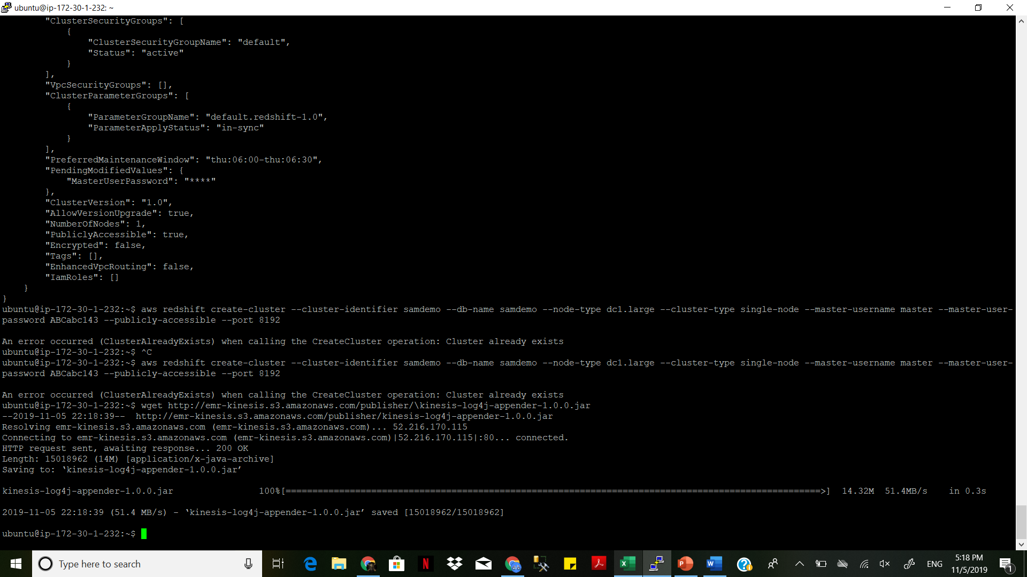

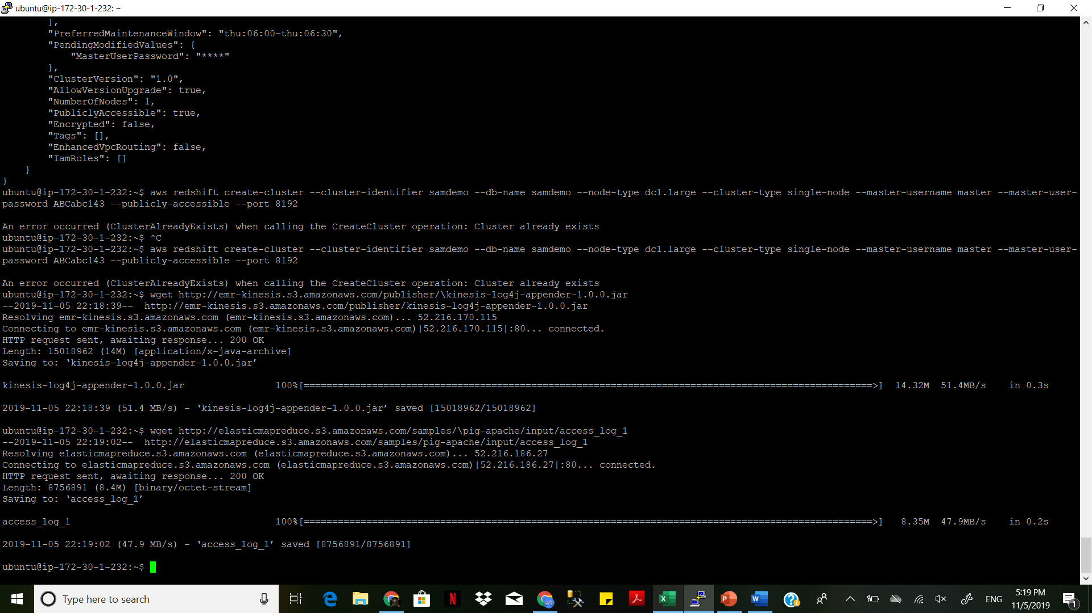

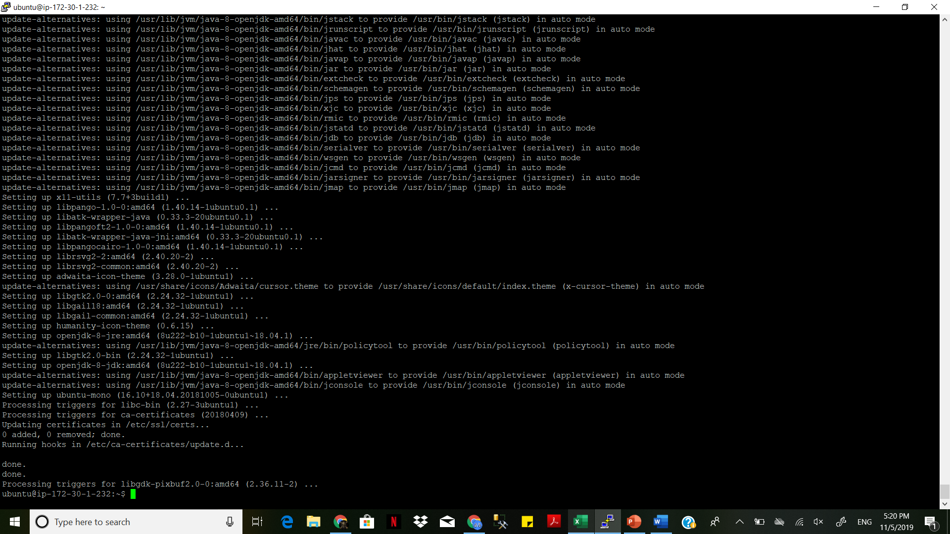

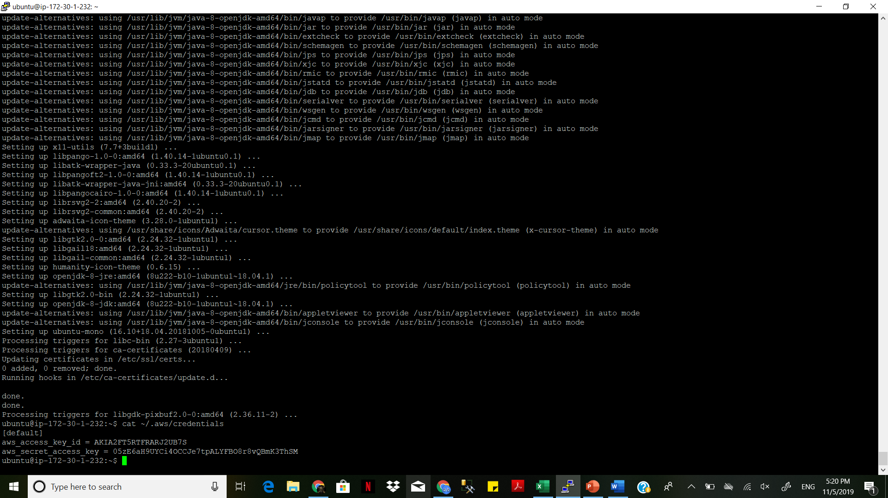

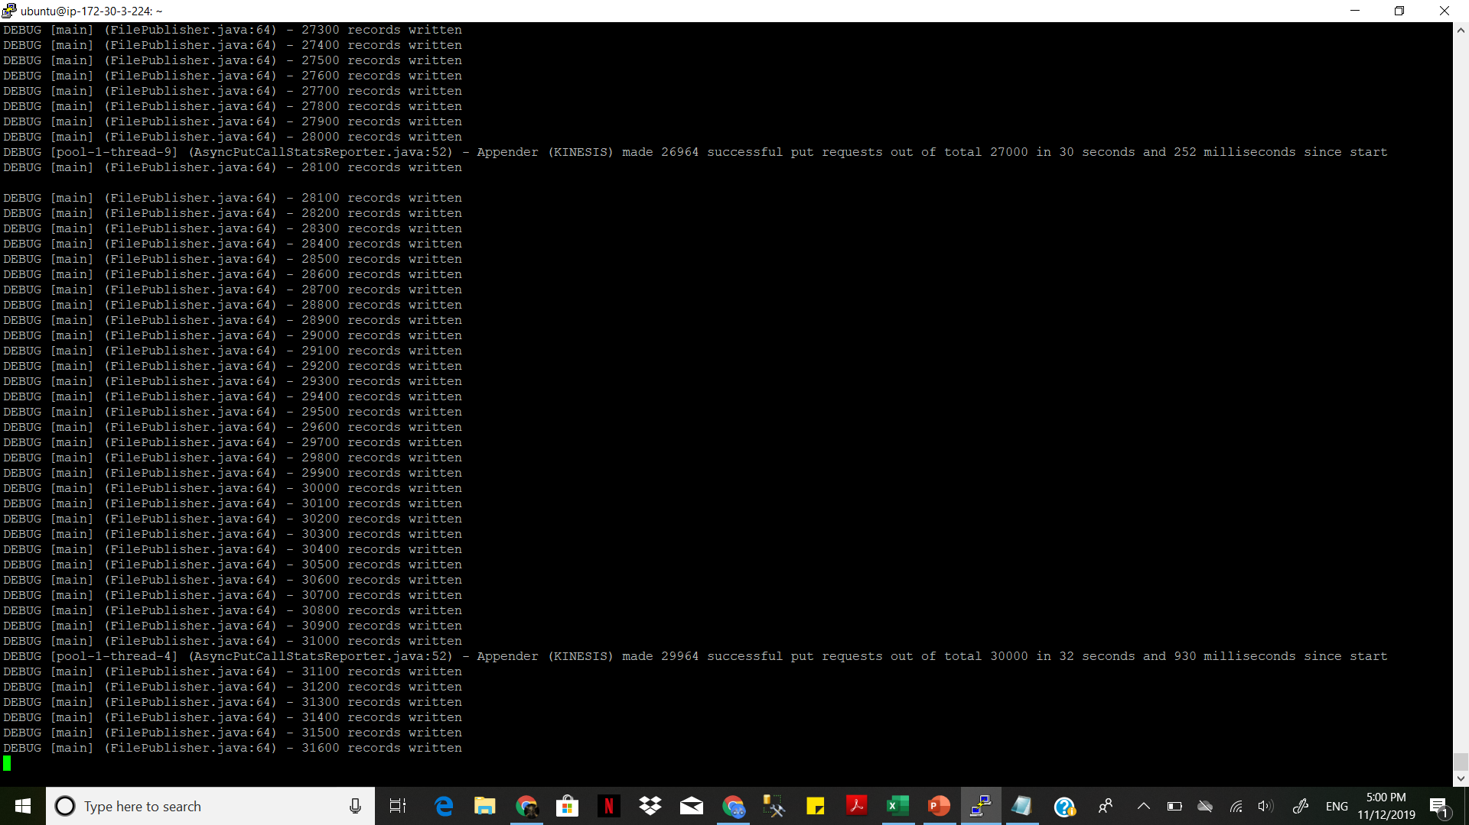

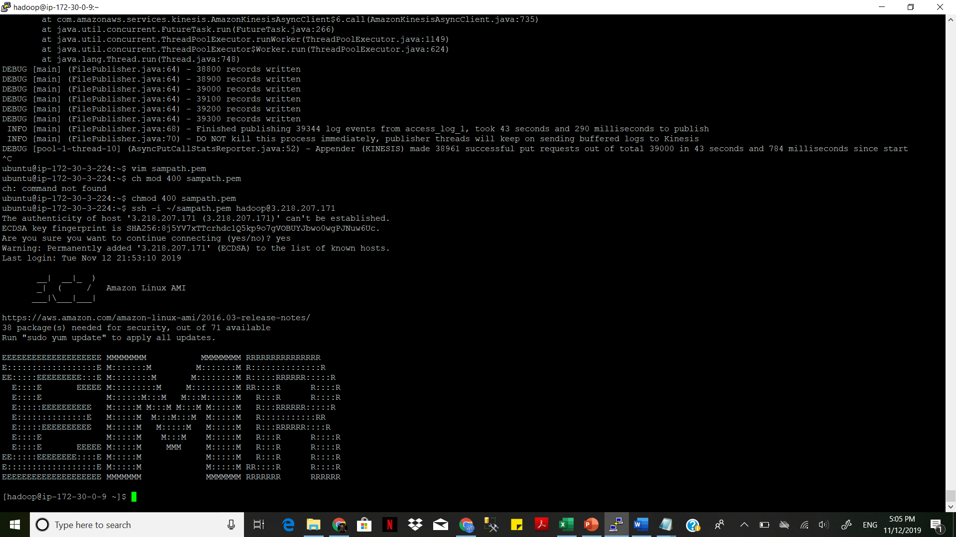

spark-shell --jars /usr/lib/spark/extras/lib/spark-streaming-kinesis-asl.jar,amazon-kinesis-client-1.5.1.jar-driver-java-options “- Dlog4j.configuration=file:///etc/spark/conf/log4j.properties”

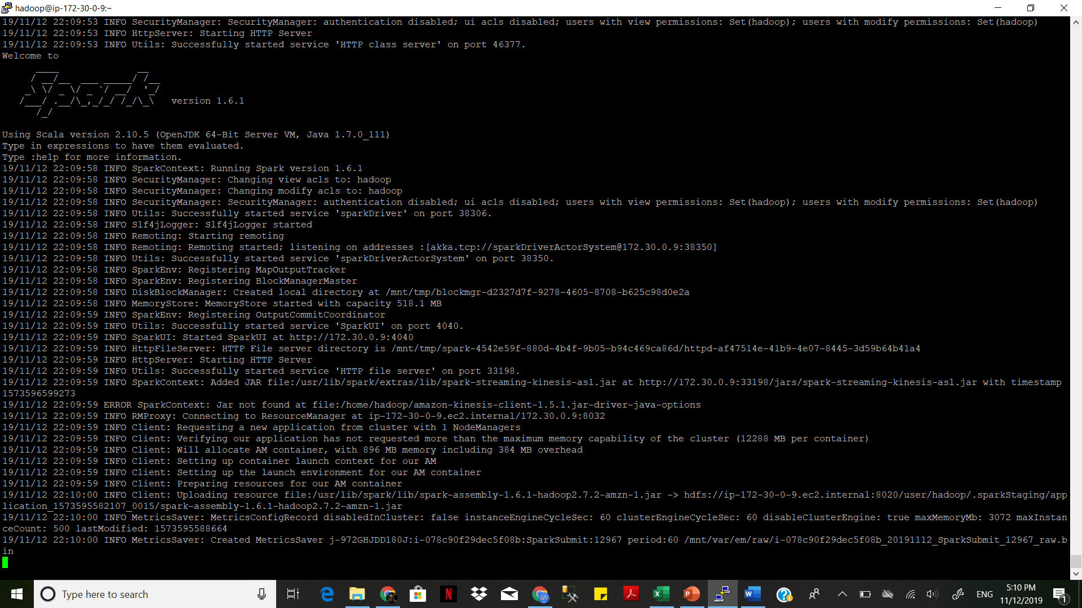

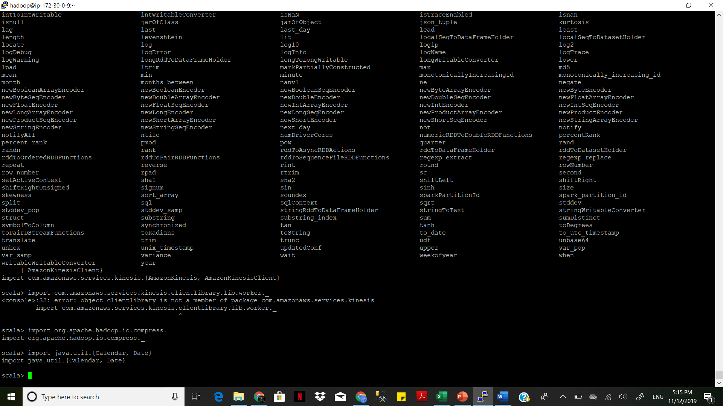

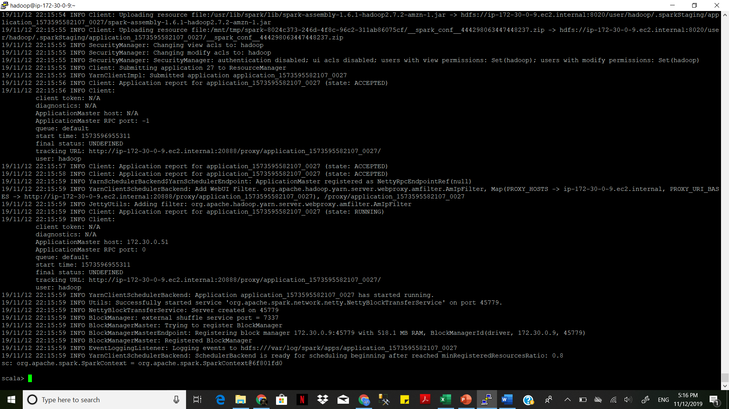

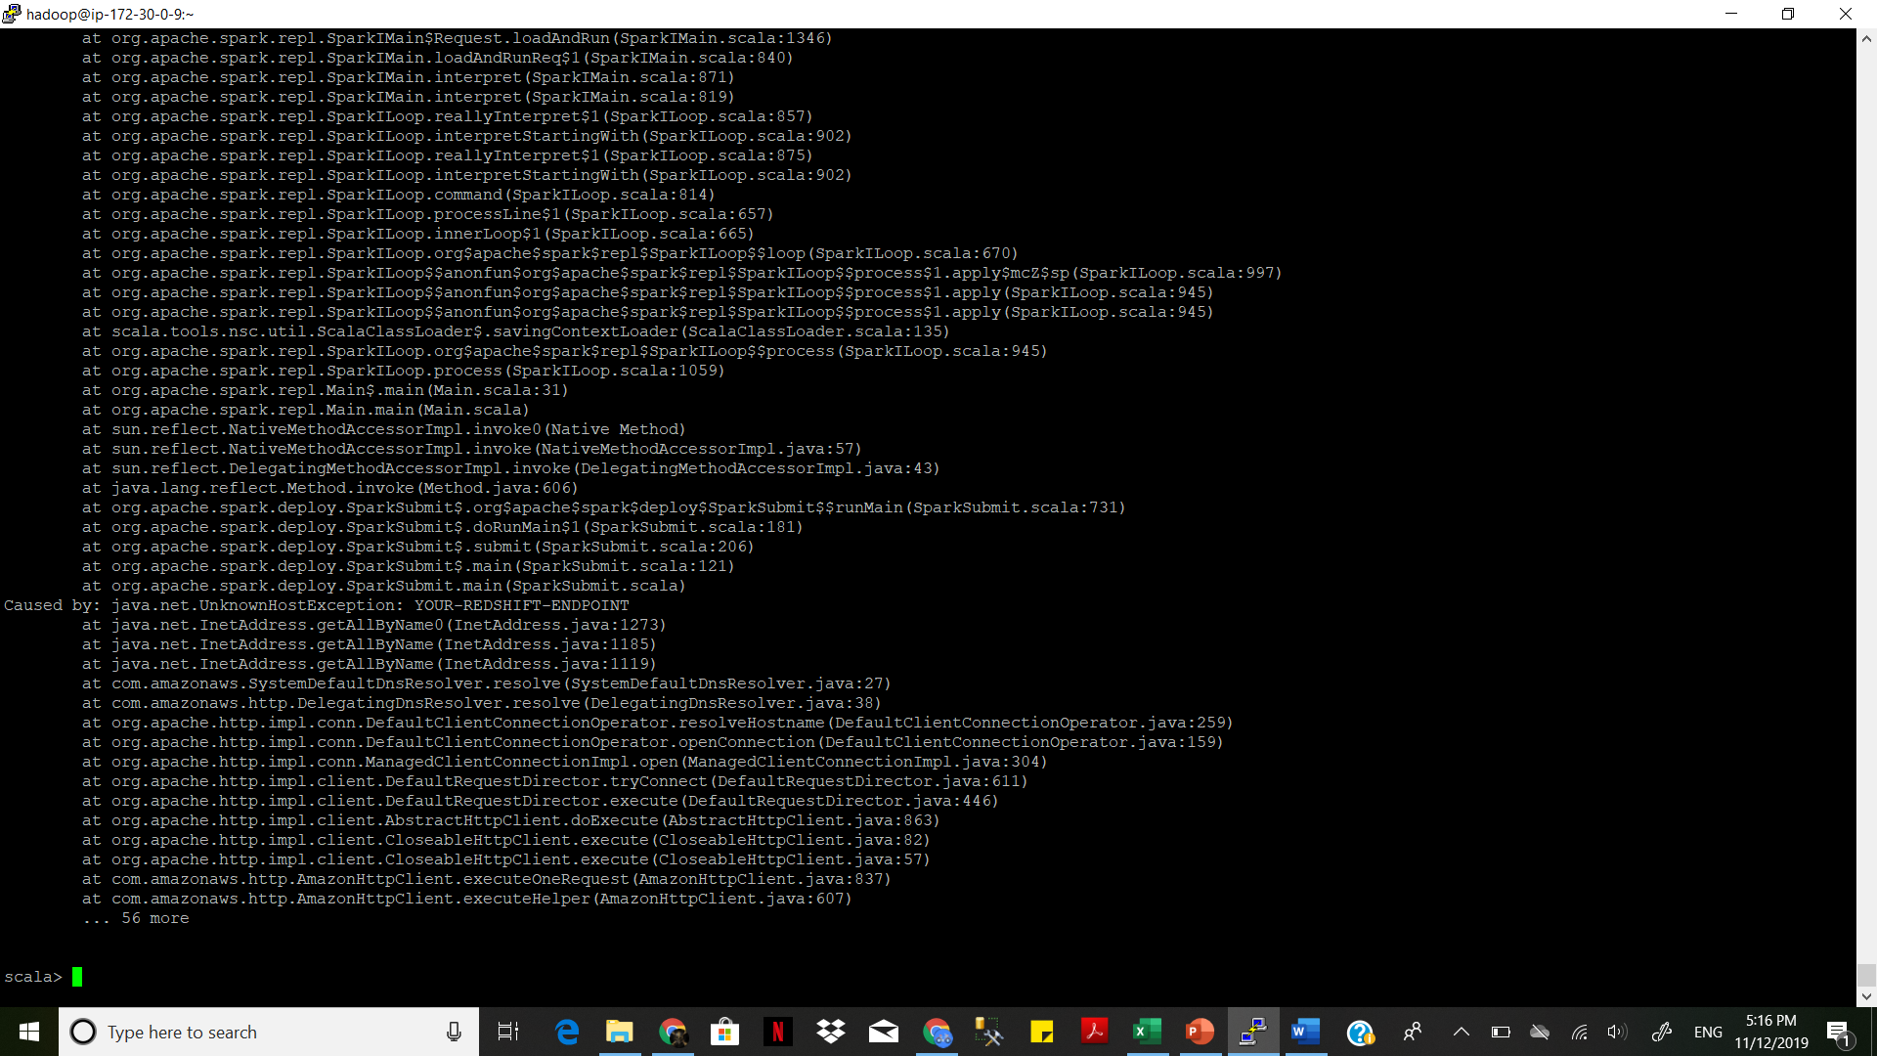

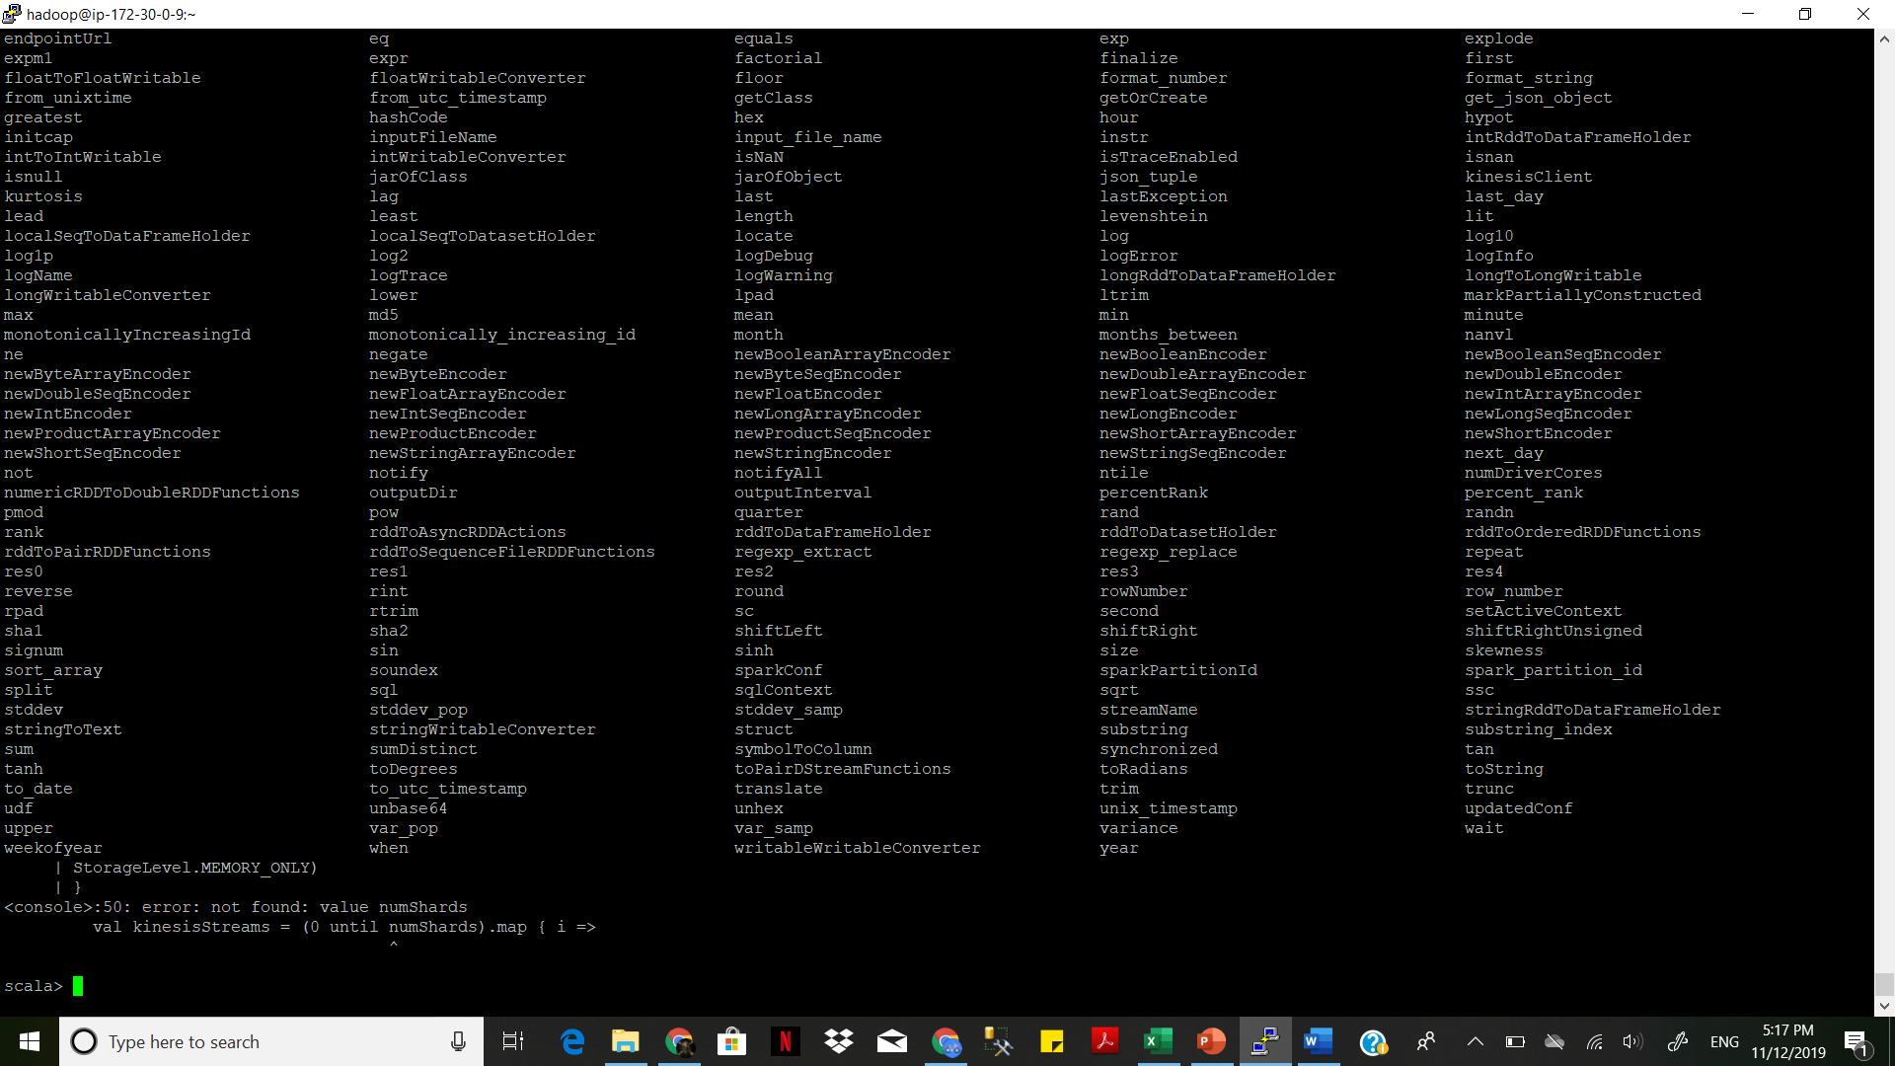

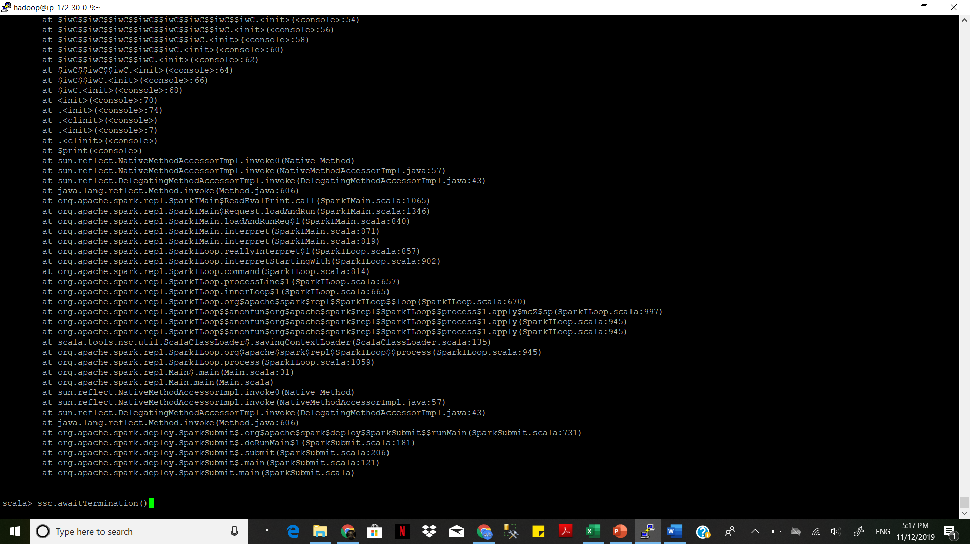

aws s3 ls s3://-f19/access-log-raw/ --recursive

aws s3 ls s3://bigdata-f19/access-log-raw/year=2019/month=11/day=12/hour=17/